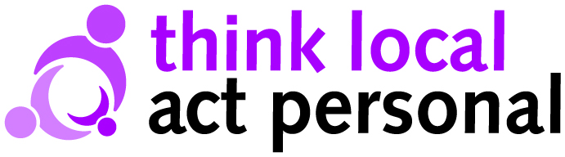

Making it Real
Markers for change

Information and Advice. Having the information I need, when I need it.
- I have the information and support I need in order to remain as independent as possible.
- I have access to easy to understand information about care and support which is consistent, accurate, accessible and up to date.
- I can speak to people who know something about care and support and can make things happen.
- I have help to make informed choices if I need and want it.
- I know where to get information about what is going on in my community.

Active and supportive communities. Keeping friends, family and place
- I have access to a range of support that helps me to live the life I want and remain a contributing member of my community.
- I have a network of people who support me - carers, family, friends, community and if needed paid support staff.
- I have opportunities to train, study, work or engage in activities that match my interests, skills, abilities.
- I feel welcomed and included in my local community.
- I feel valued for the contribution that I can make to my community.

Flexible integrated care and support. My support my own way
- I am in control of planning my care and support.
- I have care and support that is directed by me and responsive to my needs.
- My support is coordinated, co-operative and works well together and I know who to contact to get things changed.

Workforce. My support staff
- I have good information and advice on the range of options for choosing my support staff.
- I have considerate support delivered by competent people.
- I have access to a pool of people, advice on how to employ them and the opportunity to get advice from my peers.
- I am supported by people who help me to make links in my local community.

Risk enablement. Feeling in control and safe
- I can plan ahead and keep control in a crisis.
- I feel safe, I can live the life I want and I am supported to manage any risks.
- I feel that my community is a safe place to live and local people look out for me and each other.
- I have systems in place so that I can get help at an early stage to avoid a crisis.

Personal budgets and self-funding. My money
- I can decide the kind of support I need and when, where and how to receive it.
- I know the amount of money available to me for care and support needs, and I can determine how this is used (whether its my own money, direct payment, or a council managed personal budget).
- I can get access to the money quickly without having to go through over-complicated procedures
- I am able to get skilled advice to plan my care and support, and also be given help to understand costs and make best use of the money involved where I want and need this.

