Developing a Resource Allocation System (RAS):

accuracy and transparency at the heart of the indicative budget

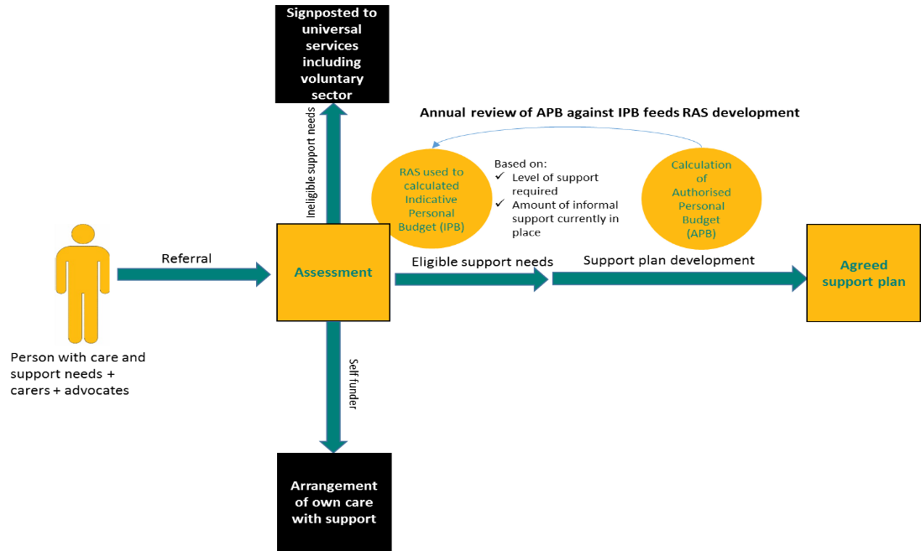
Introduction
Resource Allocation Systems (RASs) are employed across the country to provide people with an indication of the likely costs of their assessed care and support needs. Some authorities use systems developed in-house to calculate this Indicative Personal Budget (IPB), whilst others have purchased off-the-shelf RASs. In a few cases authorities use a ready reckoner approach. The variety of systems in place is a reflection of how challenging it can be to develop a RAS that meets local and national requirements successfully.
Figure 1: The RAS process in Derby
The Care Act includes requirements which have a direct impact on the implementation of a RAS. According to the Act “regardless of the process used, the most important principles in setting the personal budget are transparency, timeliness and sufficiency.” In practical terms, this means that there is a requirement to provide the person with care and support needs, and any carers or advocates who assist them, with a clear understanding of how their personal budget was calculated and confidence that the suggested amount reflects market costs and will meet the assessed needs.
This case study looks at Derby City Council’s RAS and describes how the Council has developed and maintained a RAS which has the support of staff and the local community. It draws out lessons that will enable others to review the effectiveness of their own systems and identify opportunities for improvement that reflect Care Act requirements.

Background
The Care Act sets out important principles about the calculation of an IPB which should be reflected in RAS development.
The method used to calculate the IPB must be made publicly available, even if it is based on a complex algorithm, and it must be explained in a way that the public can understand. Generally, the message is that transparent calculations are important and complex algorithmic RASs are best avoided.
There should be an upfront/indicative budget early in the process, so that the person with care and support needs understands from the start what sort of plan they can put together. Receiving a timely IPB is vital for ensuring the person’s full involvement in the process.
The amount in the Authorised Personal Budget (APB) must be sufficient to enable people to meet their care and support needs. It should allow for “reasonable” preferences to be met. The amount should take into account local market conditions and there must be at least one provider of a good quality service (e.g. compliant with registration requirements and national quality standards such as ASCOF) that can be afforded within the personal budget. The RAS needs to reflect this.

Developing a RAS in Derby
Derby is a unitary authority located in the East Midlands which serves a population of over 250,000. Approximately 3,000 people receive social care services in the area. Derby is a relatively deprived authority with 28.7% of the local population living in the 20% most deprived wards in England. The current RAS in use in Derby builds upon the experience gained from using two earlier RASs which were both developed in-house. The current version of the tool is less complicated than its predecessors to make it more user friendly.
The RAS tool is in Excel format and has an input form (Appendix A) which is completed by the social worker after the assessment based on the responses given to specific questions. An output form (Appendix B) summarises the needs of the person with care and support needs, automatically allocating a number of points based on the responses from the input form and calculating an overall eligibility score. This score is based on a slightly modified version of the weighting from the latest version of the Common Resource Allocation Framework. The weighting reflects the Fair Access to Care Services (FACS) criteria and bandings. Once a score has been obtained an IPB is calculated using an Allocation Table.
Figure 2: Evolution of the RAS tool in Derby

Design led by key fundamentals
- The RAS needs to be simple and easy to use for all: A review of the second Derby RAS highlighted the need to reduce its complexity. Addressing this issue was a key reason for developing the current RAS.
- It is essential that users accept that the RAS is indicative: Staff in Derby have been trained in the use of the RAS and this training has stressed the importance of explaining the indicative nature of the RAS. The RAS is seen as a tool to obtain an idea of support costs for planning purposes.
- A single RAS can be used for all adult client groups: The Derby RAS is used to generate an IPB for older people, people with physical disabilities, people with learning disabilities and people with mental health needs. The RAS only includes funding for community-based social care support. Health related funding is excluded.
- Carers have a separate RAS: The Derbyshire Carers Association uses a carers RAS developed by Derby City Council to decide on eligibility for one-off carers payments.
- It is important to be aware of the relationship between the RAS and the local context: The amount in the Authorised Personal Budget should take into account local market conditions and there must be at least one provider of a good quality service. By conducting an annual review of the APB against the IPB generated by the RAS for each individual, the RAS tool is as accurate as possible.
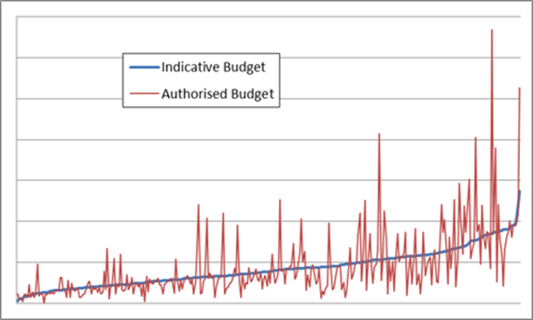
- A RAS based on accurate, and up to date data, can assist with budgetary planning: The annual review highlights potential pressures on the social care budget and can be used as evidence to support future reallocation of resources.
- Building on the learning from a nationally developed tool improves the quality of the RAS and helps to engender local support for the system: The national tool was developed based on input from 18 councils and citizen leaders (disabled people and family members) and an extensive consultation exercise. The charity In Control provided expert advice. Incorporating this knowledge and experience into the development of the RAS has enabled Derby City Council to avoid the mistakes of others and helped to convince key stakeholders of the legitimacy of the system.
Figure 3: IPB allocation developed through the RAS against calculated APB
Keeping the Care Act principles at the core of the RAS
The Derby team recognises that a RAS based on the old FACS criteria will need modification in order to reflect the 10 new Care Act outcomes and the associated approach to determining eligibility. Their plan is to revise their Excel tool based on this new approach. As part of upgrading their social care IT system they are planning to align the RAS more closely with their social care processes by building the functionality of the Excel tool into the system. Once the new system is in place there are also plans to make the RAS available online as part of a customer portal.
Have you considered how well your RAS meets the Care Act requirements of transparency, timeliness and sufficiency?
Do you have plans in place to ensure that your RAS will be Care Act compliant?

References

Care Act 2014
http://www.legislation.gov.uk/ukpga/2014/23/contents/enacted

Common Resource Allocation Framework
http://www.thinklocalactpersonal.org.uk/Latest/Resource/?cid=6376

Appendix A – Screenshot of page 1 of the Derby RAS input questionnaire

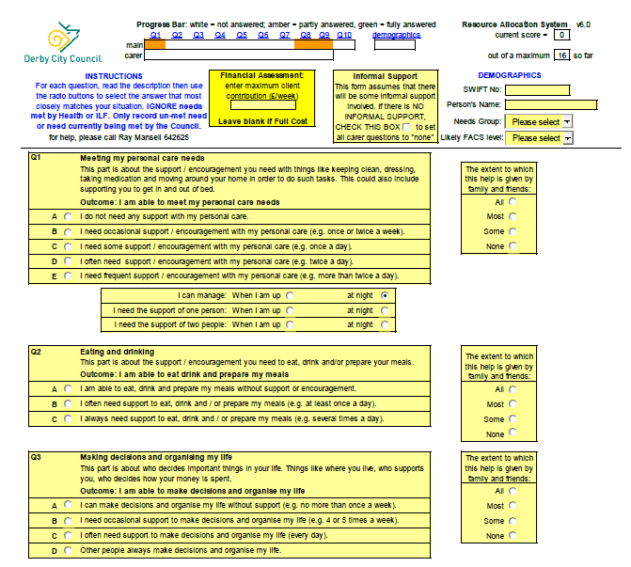

Appendix B – Screenshot of page 1 of the Derby RAS output form

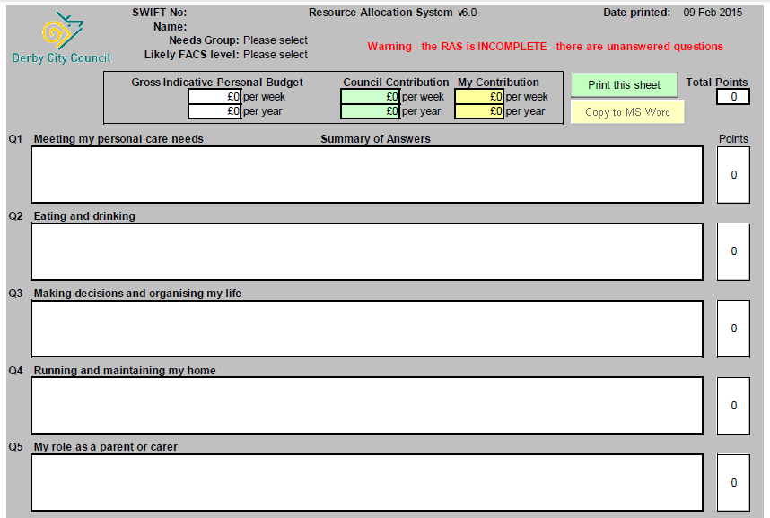

Care and Support Statutory Guidance, Department of Health, October 2014, page 191 (https://www.gov.uk/government/uploads/system/uploads/attachment_data/file/366104/43380_23902777_Care_Act_Book.pdf)
Derby Unitary Authority Health Profile, Public Health England, 12 August 2014 (http://www.apho.org.uk/resource/view.aspx?RID=142168)
2013/14 P2S figure from RAP data collection, National Adult Social Care Intelligence Service (NASCIS) Online Analytical Tool, Health and Social Care Information Centre.
Common Resource Allocation Framework (updated June 2010), ADASS, (http://www.thinklocalactpersonal.org.uk/Latest/Resource/?cid=6376)
inControl, the body that first developed the RAS concept, and which continues to develop thinking and practical applications on the RAS is understood to be developing a paper in February 2015 that will look at how best to approach the assessment and resource allocation system in the era of the Care Act.

