**Efficient IT systems to support collecting the right information**

*“Information, information, information – without it, how can people be truly at the heart of decisions?”*

*–* ***Public response to the Caring for our Future engagement***

# **Introduction**

Information Technology (IT) systems underpin the modern social care process. They provide a consistent method for recording key information about those who contact services and sharing this with the right people, at the right time and in the right formats. IT systems are used to collect data for a number of purposes including internal management, statutory duties and performance requirements of the Health and Social Care Information Centre (HSCIC). Ensuring that these systems work efficiently and record only what is required is an ongoing challenge for local authorities, particularly at a time of significant change in the social care sector.

***Updated IT systems are critical to successful delivery***

The Local Government Association (LGA) stresses that *“Every council with responsibility for social care will have IT systems in place to manage their case records. The care and support reforms will change the requirements of these systems. Having in place the right information systems to support the reforms is critical to successful implementation. Every council has a responsibility to work with their suppliers to ensure systems will meet the requirements of the care and support reforms.”*

A high level specification for the information and technology changes required for successful implementation of the Care Act, [Informatics Specification for Care Act Implementations-Core Systems (PDF)](http://www.local.gov.uk/documents/10180/5756320/Informatics+Specification+for+Care+Act+Implementations-Core+Systems/eafe2232-a6c4-48f9-be9b-2302d89bfeb9), was developed in July 2014. This specification includes the key implications for systems that arise from the Act.

Throughout 2014, the Department of Health, working with ADASS IN, issued several updates to provide advice to local authorities and adult social care IT Suppliers on Care Act requirements and the wider information and technology agenda for health and social care. [Informatics Specification for the Care Act Part 2 Implementation (PDF)](http://www.local.gov.uk/documents/10180/5756320/Informatics+Specification+for+Care+Act+Part+2+Implementation/2aece5f2-e7de-4580-b5c9-a777d4a4aaa4)[1] is a February 2015 update that describes recent developments and required and desirable system changes.

This case study looks at Derby City Council’s upgraded social care IT system and the opportunities that it has provided to make their processes more efficient and address the requirements set out in the Care Act.

# **What does the Care Act say about the information that needs collecting?**

|  |
| --- |
| The Care Act 2014 requires local authorities to ensure that any adult with an appearance of care and support needs, and any carer with an appearance of support needs, receives an **appropriate** and **proportionate** assessment to identify the extent of their need. Information should be collected with this in mind. Local authorities are required to collect the data and information they need to ensure they meet **general requirements**, such as the Equalities Act. |
| Information that should be gathered at the assessment stage includes:   * The **person’s needs** and how they impact on their wellbeing – for instance, a need for help with getting dressed or support to get to work; * The **outcomes** that matter to the person – for example, whether they are lonely and want to make new friends; * The person’s **other circumstances** – for example, whether they live alone or whether someone supports them   The aim is to get a **full picture of the person** and what **needs and goals** they may have.[2] |
| All requirements under the Care Act, for instance to support carers, or people to whom there’s a wellbeing duty under Sec.1, require sufficient data collection in order for local authorities to be able to carry out the duty effectively (see ‘Things to think about’ below). |
| Performance data must be gathered in line with the ASCOF[3] requirements, which is not replaced by the Care Act 2014. |

# **Updating the IT system in Derby­**

Derby City Council is a unitary authority located in the East Midlands which serves a population of over 250,000.[4] Approximately 3,000 people receive social care services in the area.[5] Derby is a relatively deprived authority with 28.7% of the local population living in the 20% most deprived wards in England. The contract for Derby’s existing social care IT system was coming to an end so the Council saw this as an opportunity to review their business processes and to ensure that their system was able to support 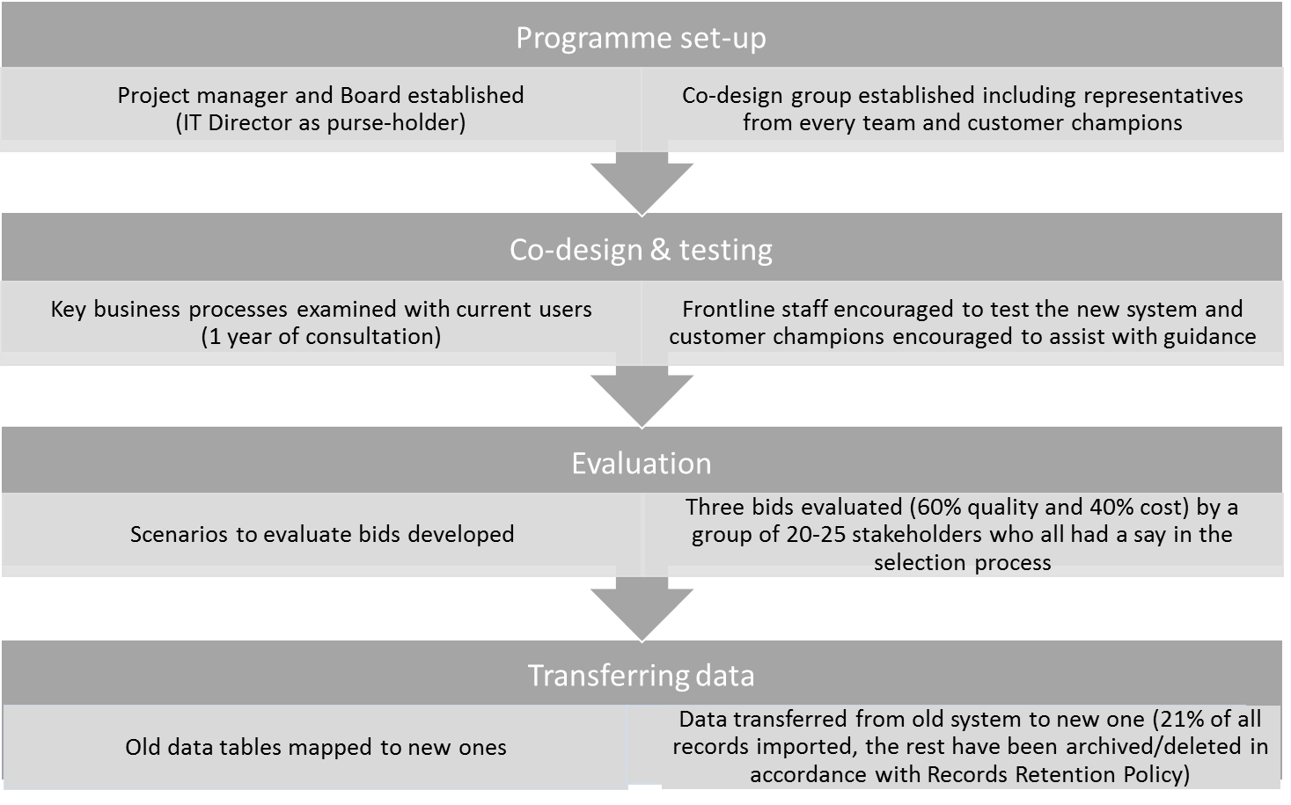these processes more efficiently. Their key aim was to collect information once and avoid duplication of effort.

Upgrading the IT system used in Derby was driven by a desire to improve:

* running costs
* user experience (simplified processes and easier navigation)
* interoperability with other systems
* information management and reporting
* the collection of key information
* the ease of introducing system upgrades.

The commissioning and implementation process for the new system has involved several key steps which have taken approximately 18 months from start to finish.

Figure : Key steps involved in developing Derby's new social care IT system

***Easy to access and safe to store***

The new system collects the same data as previously, with a few additional fields – Derby’s motto is: *“collect lots and use many times!”* The key difference is in significant improvements to functionality. This includes features such as: automatic exporting of data between forms to remove duplicate data entries; a better save function; better step-by-step guidance provided for users; missing / mandatory fields highlighted; additional interoperability; ability to easily configure if required; and the introduction of role-based security. The anticipated benefits of Derby’s new IT system and how they will impact on local business processes are set out in Appendix A. These benefits are described in more detail below:

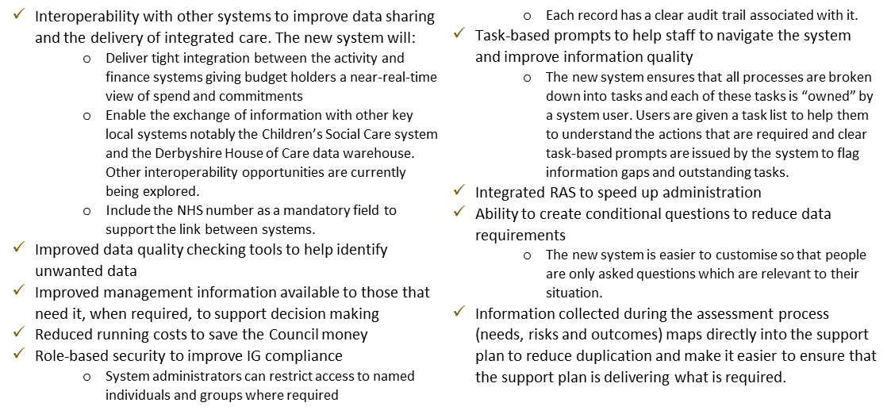

***A future-proof system***

Derby is planning to make several further improvements to their new system to ensure Care Act compliance. Notable changes include ensuring that self-funders and carers can easily be identified on the system. They are also reviewing their carers assessment which is not currently part of the system.

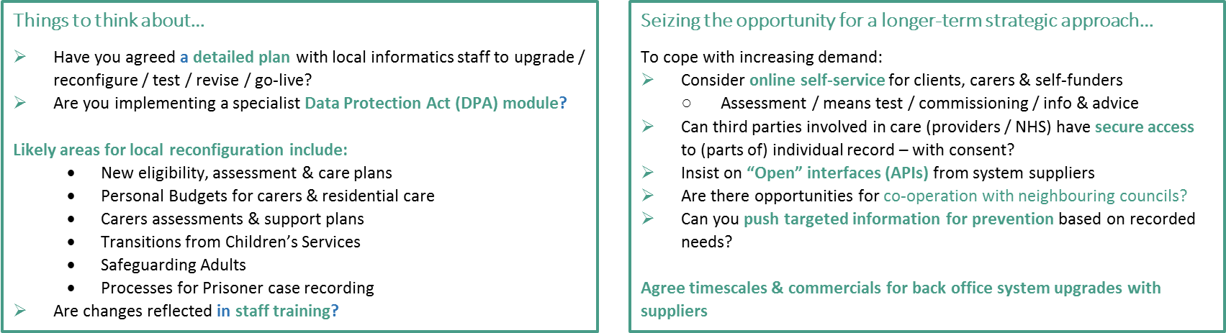

*Information taken from Richard Pantlin presentation, 3rd Feb 2015,* ***London Social Care Information Management Group, ADASS Informatics Network***

# **References**

**Care Act 2014**  
<http://www.legislation.gov.uk/ukpga/2014/23/contents/enacted>

**Local Government Association Care and Support Reform Informatics Specification**

<http://www.local.gov.uk/care-support-reform/-/journal_content/56/10180/5831592/ARTICLE>

**Adult Social Care Outcomes Framework 2015-16**

<https://www.gov.uk/government/publications/adult-social-care-outcomes-framework-ascof-2015-to-2016>

**Health & Social Care Information Centre (HSCIC)**

http://www.hscic.gov.uk/

# **Appendix A - Opportunities to improve processes created by new IT system in Derby**

This diagram illustrates the potential process improvements around data sharing and collection that can be realised through the implementation of a new IT system in Derby.



1. <http://www.local.gov.uk/care-support-reform/-/journal_content/56/10180/5831592/ARTICLE>
2. <http://www.scie.org.uk/care-act-2014/assessment-and-eligibility/appropriate-proportionate/>
3. Adult Social Care Outcomes Framework 2015-16, <https://www.gov.uk/government/publications/adult-social-care-outcomes-framework-ascof-2015-to-2016>
4. Derby Unitary Authority Health Profile, Public Health England, 12 August 2014, <http://www.apho.org.uk/resource/view.aspx?RID=142168>
5. 2013/14 P2S figure from RAP data collection, National Adult Social Care Intelligence Service (NASCIS) Online Analytical Tool, Health and Social Care Information Centre.