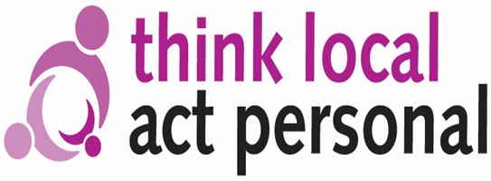

Building Community Capacity Practitioners Network Meeting
Birmingham Voluntary Service Council
Thursday 7th September 2017

Let’s Talk About Evidence

Purpose and context

The sector wide Engaging and empowering communities: Our shared commitment and call to action made a clear commitment to improve the evidence base for community based approaches to care and support (see box below).

Evidence and Simple Measurements

“There is a significant evidence base for the benefits of empowering and engaging communities, but often it is dissipated and available way in ways that make local comparison and evaluation difficult. Getting smarter at improving health and wellbeing through empowering and engaging communities will require a better, shared understanding of what good looks like and how to measure it. This must go beyond blunt proxy measures, such as reduced hospital admissions and help to articulate the broader benefits to the system and to communities in the medium and longer term in a clear and consistent way”

Engaging and empowering communities: Our shared commitment and call to action, TLAP, 2016

At this forthcoming BCC Network meeting we will hear about innovative community based approaches to improving health and wellbeing and the challenge of creating the evidence that demonstrates their positive impact. There will be an opportunity to share what people are doing in the area of evidence and identify what can be done to overcome the ‘evidence paradox’, whereby innovation is stifled because of a perceived lack of the right sort of evidence. A circular argument, so that if we never attempt to deliver new community based approaches, we can never prove it works.

